|  |
| --- |
| IT1B |
| Project Innovate |
| A smart solution to finding friends for your dog |
| Philip, Hylke, Hemran, Muhitdin, Patrick, Nadie  5-10-2019 |

Contents

1. Introduction
2. Sequence Diagram
3. Data Flow Diagram
4. Entity Relationship Diagram

Introduction

IT1B was tasked with creating an innovative project under “Project Innovate” by NHL Stenden. IT1B came up with the idea of creating a “Tinder clone” for animals named “Breedr.” The goal is to create a working prototype of an innovative idea.

Breedr is a mobile app based off the famous app Tinder, Breedr is different as it is not for humans but rather for animals, these animals include dogs, cows, horses etc., but the prototype of the app will only allow dogs. Breedr has the same simple functionality of tinder. You will create an account and with this account you can swipe left or right to match with other users to set up playdates for your animals or for breeding. The app will be created on android studio and will include an AI created by IT1B that will be taught to recognize dogs for images to stop fake or spam accounts from being made.

The reason IT1B decided to make Breedr was due to all the employees being interested in the creation of apps and the implementation of AI and deep learning.

The full functionality of the app will be explained in the next 2 chapters and in Appendix A: Storyboard of Breedr.

Sequence Diagram

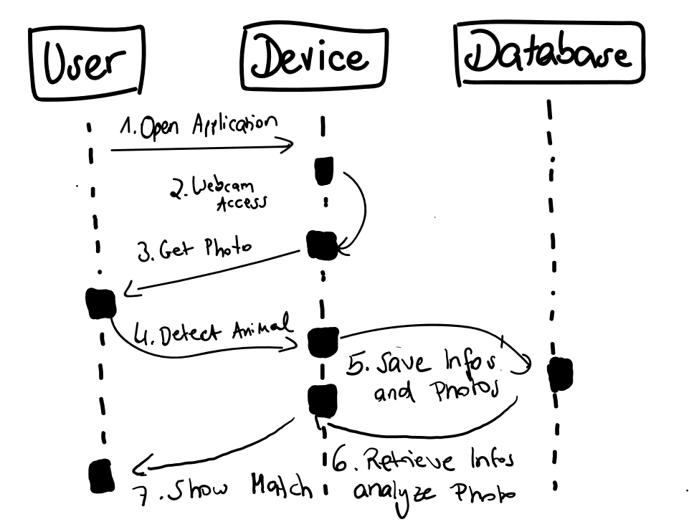

Data Flow Diagram

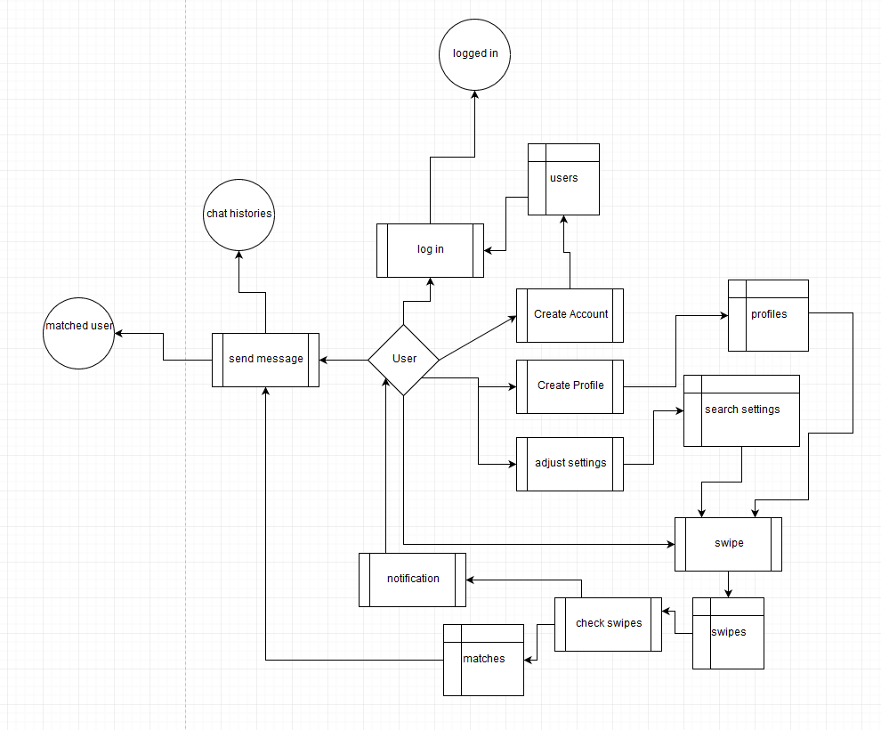

Entity Relationship Diagram